

ASSIGNMENT-10

# PYTHON

# **NAME : MADA SRAGVIN KUMAR**

# **MIS NO : 112315097**

# **GROUP : 3**

**YEAR : 2**

**SECTION : A**

# **1:**

Test23:

bye bye tata tata good bye sragvin.

f=open("D:\\teststxt\\test23.txt","r")

k=f.read()

a=[]

d={}

l=k.split()

for i in l:

if i not in a:

a.append(i)

d.update({i:l.count(i)})

dl=dict(sorted(d.items()))

f.close()

f1=open("D:\\teststxt\\newtest.txt","w")

f1.write(str(dl))

f1.close()

f2=open("D:\\teststxt\\newtest.txt","r")

print(f2.read())

f2.close()

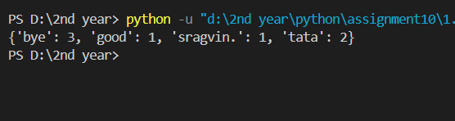

# **2:**

f3=open("D:\\2nd year\\txt\\test2.txt","w")

l=["D:\\teststxt\\test23.txt","D:\\teststxt\\newtest.txt","D:\\2nd year\\txt\\test.txt"]

str=""

for i in l:

f=open(i,"r")

str=str+f.read()+" "

f3.write(str)

f3.close()

f4=open("D:\\2nd year\\txt\\test2.txt","r")

print(f4.read())

f4.close()



# **3:**

import keyword

a=keyword.kwlist

f=open("D:\\teststxt\\test23.txt","r")

ml=[]

l=f.readlines()

print(l)

f.close()

for i in l:

for k in i.split("\n"):

for j in k.split():

if j in a:

ml.append(k)

f1=open("D:\\teststxt\\newtest.txt","w")

for i in ml:

f1.write(i+"\n")

f2=open("D:\\teststxt\\newtest.txt","r")

print(f2.read())

f2.close()

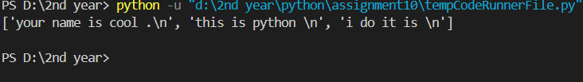

# **4:**

import os

path=r"D:\\2nd year\\txt"

path1=r"D:\teststxt"

try:

for root,dir,files in os.walk(path):

for file in files:

os.system(f'copy "{os.path.join(path,file)}" "{path1}"')

except:

print("File is not found")

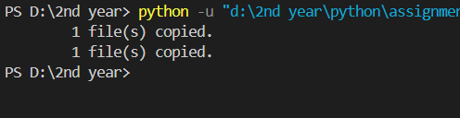

# **5:**

with open("D:\\2nd year\\txt\\test.txt","r") as f:

mystr=f.read()

mylist=mystr.split("\n")

mylist2=[i[::-1] for i in mylist]

with open("D:\\2nd year\\txt\\test2.txt","w") as f2:

for line in mylist2:

f2.write(line+"\n")

.ramuk nivgars si eman ym

# **6:**

import os

path=r"D:\\2nd year\\txt"

def size(path):

ts=0

for root,dirs,files in os.walk(path):

for file in files:

ts+=os.path.getsize(os.path.join(root,file))

return ts

for root,dir,files in os.walk(path):

print(f"The size of {root} is {size(root)}")

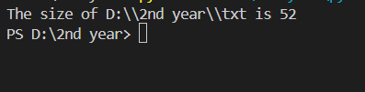

# **7:**

import os

from datetime import datetime

tgt_st=datetime(year=2024,month=9,day=28)

fpath=r"C:\\Users\\sragv\\OneDrive\\画像\\Saved Pictures"

for root,dirs,files in os.walk(fpath):

for fn in files:

newfp=os.path.join(root,fn)

if datetime.fromtimestamp(os.path.getmtime(newfp))<tgt_st:

print(f"{newfp} ,this file has been deleted")

os.remove(os.path.join(root,fn))

# **8:**

import os

path=r"C:\\Users\\OneDrive\\Desktop"

def organize_files_by_extension(directory):

for filename in os.listdir(directory):

if os.path.isdir(filename):

continue

extension = os.path.splitext(filename)[1][1:]

if not extension:

continue

if not os.path.exists(extension):

os.makedirs(extension)

os.rename(filename, os.path.join(extension, filename))

organize_files_by_extension(path)

# 

# **9:**

import os

from datetime import datetime

path=r"C:\\Users\\91944\\OneDrive\\Desktop\\backup_directory"

for root,dirs,files in os.walk(path):

for file in files:

print(f"Name of file:{file}")

print(f"Size :{os.path.getsize(os.path.join(root,file))}")

ls=os.path.getmtime(os.path.join(root,file))

print(f"Last Modified date:{datetime.fromtimestamp(ls)}")

print("\n")

# **10:**

import os

path=r"C:\\Users\\OneDrive\\Desktop\\backup_directory"

my_files=[]

seen=[]

for root,dirs,files in os.walk(path):

for file in files:

with open(os.path.join(root,file),'r') as f:

my_files.append((os.path.join(root,file),f.read()))

for a in my_files:

if a[1] not in seen:

seen.append(a[1])

else:

print(a[0])